**SEDABAVI HEMANTH REDDY**

**REG.NO: 19001177**

**DAY: 5 TASK**

**1)**

**2)**

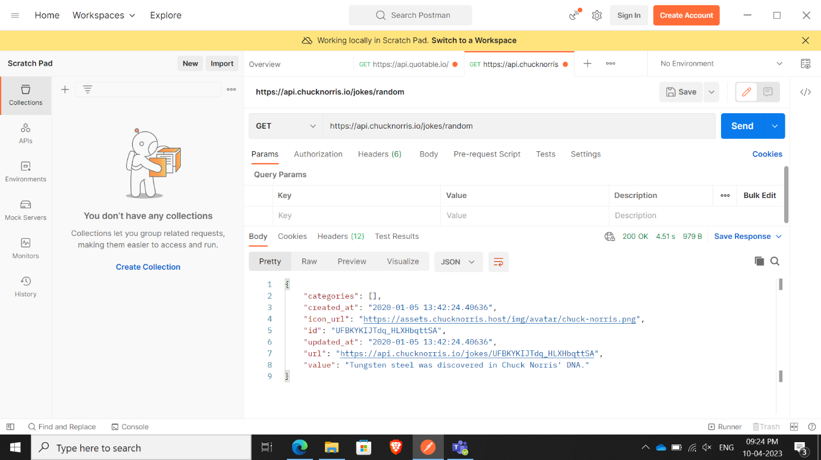

**4)**

**5)**

